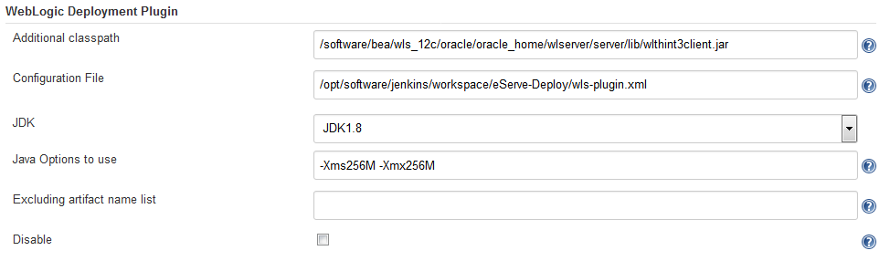

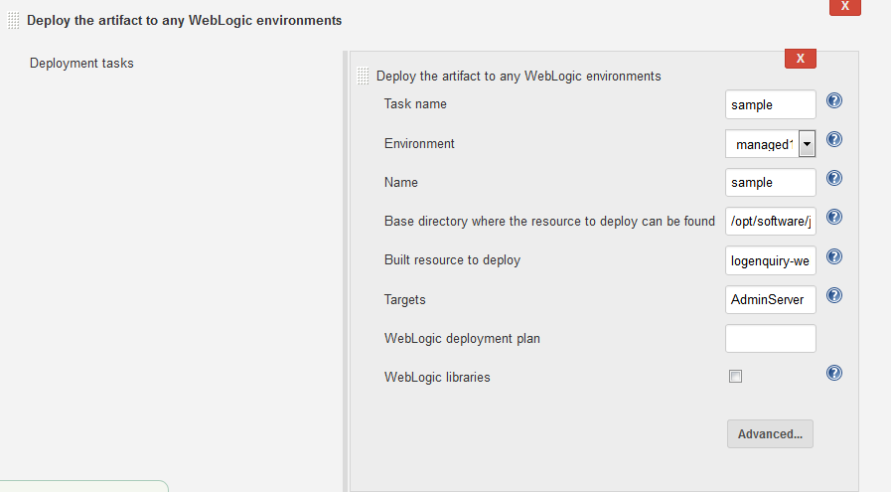

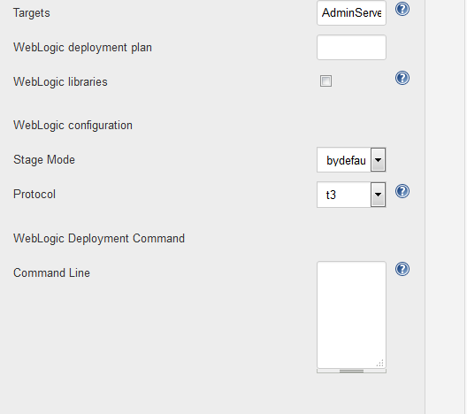
Config.xml:
<?xml version="1.0" encoding="UTF-8"?>
<config xmlns="http://org.jenkinsci.plugins/WeblogicDeploymentPlugin"
xmlns:xsi="http://www.w3.org/2001/XMLSchema-instance"
xsi:schemaLocation="http://org.jenkinsci.plugins/WeblogicDeploymentPlugin plugin-configuration.xsd">
<weblogic-targets>
<weblogic-target>
<name>managed1_eservewlst01</name>
<host>_weblogic.admin.server.host_</host>
<port>_weblogic.admin.server.port_</port>
<login>_weblogic.admin.server.login_</login>
<password>_weblogic.admin.server.password_</password>
<authMode>BY_LOGIN</authMode>
<userconfigfile>/opt/software/jenkins/workspace/eServe-Deploy/eServe_EC.properties</userconfigfile>
</weblogic-target>
</weblogic-targets>
Properties refered in config.xml:
#WebLogic details
_weblogic.admin.server.login_=weblogic
_weblogic.admin.server.password_=*****(Masked for your ref)
_weblogic.admin.server.host_=XX.XX.XX.XX (Masked for your ref)
_weblogic.admin.server.port_=XXXXX(Masked for your ref)

